**Assignment 3**

**Topics in Software Engineering**

**Group**

**Ahmad Mujtaba FA19-BSE-113**

**Hamza Aziz FA19-BSE-001**

**M. Abubakar FA19-BSE-079**

**M. Afzan Ahsan FA19-BSE-053**

**Submitted To: Dr Fatima Sabir**

**Fare Calculator**

**Class Diagram**

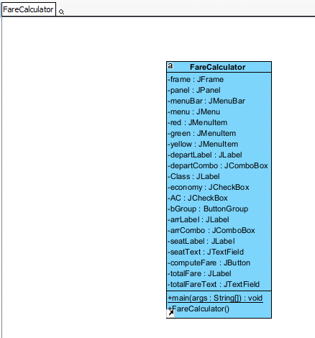

There is only one class in the given project. The FareCalculator class has many functions and variables which can be seen through the above diagram. The FareCalculator constructor is called in the main function of the class.

**Jira Work Schedule**

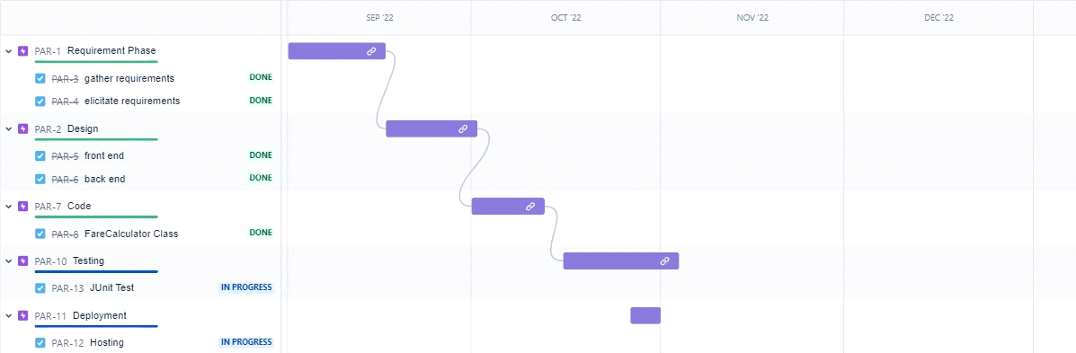

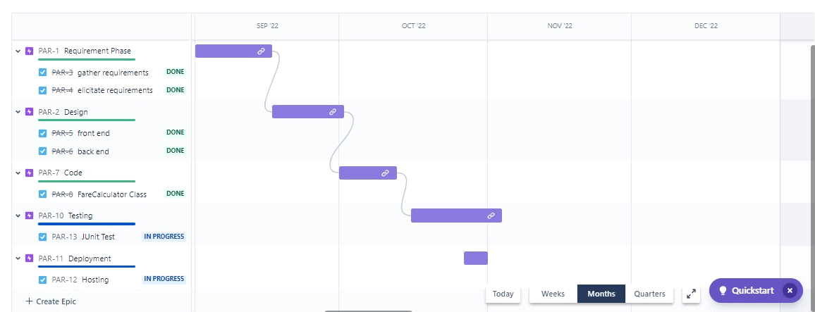

As we can see through the above first image that our deployment and testing phase is in progress while the requirement and design phase has been completed.

Afzan ahsan is doing testing while hamza aziz is coding and Ahmad Mujtaba is handling requirements and design phase.

Starting date of this project is 1st of September 2022 and the ending date is 31st 2022.

Requirement Phase starts from 1st September and ends on 15th September 2022.

Design phase will start on 15th of September 2022 and ends on 1st of October 2022.

Coding phase starts on 1st of October and ends on 7th of October.

Testing phase starts on 7th of October and goes to 31st October.

**Coding**

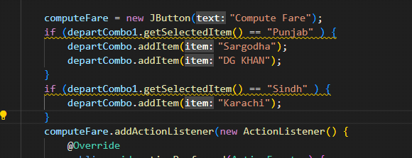

As you can see in this code I have created a combo box of provinces in which I have added items in “if statements”.

If combo box selected item is equal to Punjab then the relevant cities of Punjab such as Islamabad will be there in the combo. Similarly If combo box selected item is equal to Sindh then the relevant series of Sindh such as Karachi will be there in the combo. i.e.

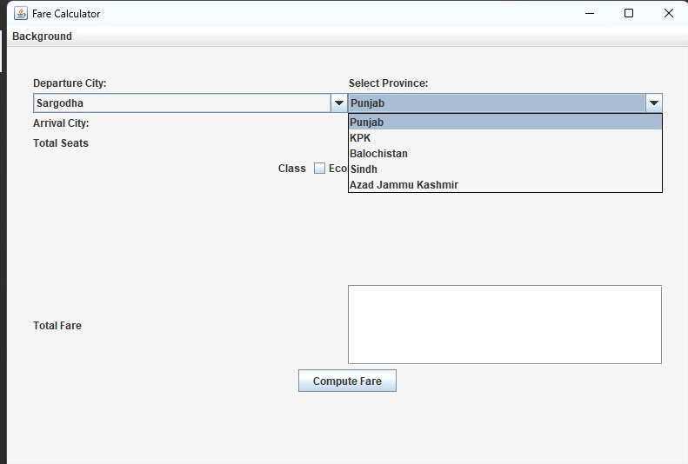

**GitHub**

Updated java code is commited to github repo.

Link for Github Repo is here : <https://github.com/HamzaAziz001/TSE_Assignment03>

**Updating after adding Sprints**

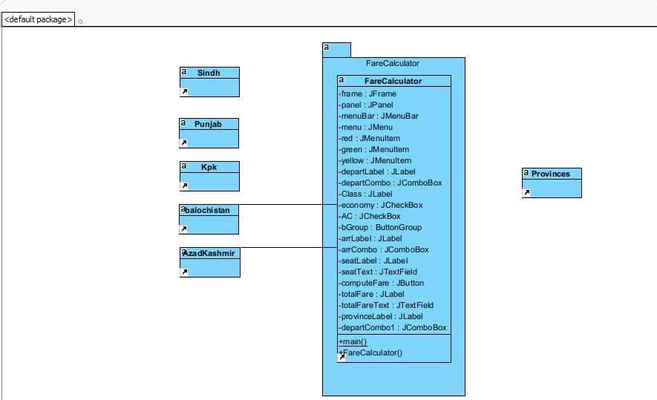

After successfully adding required changes in code such as adding different provinces with respective cities, the updated class diagram looks like this. So, our class diagram is now changed.